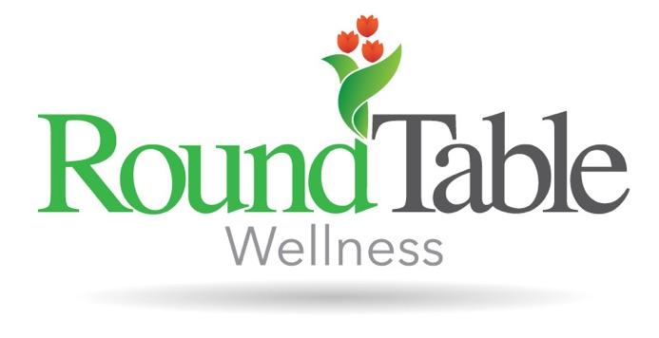
Gabriela received her bachelor’s degree from Purdue University and went on to complete her dietetic internship as a Purdue Boilermaker. She is a Registered Dietitian Nutritionist accredited by the Commission on Dietetic Registration. Prior to her work with RoundTable Wellness, Gabriela worked with high risk prenatal women and their children at Women, Infants, and Children Supplemental Nutrition Program. There she strived to provide participants with understandable, easy to access nutrition information to help children grow in an environment that promotes positive mindsets around food and focus less on weight stigma. She believes that no bodies are meant to look the same and mental health should never be sacrificed to comply with the messages of diet culture. Using a non-judgmental and weight inclusive approach, Gabriela provides evidence based information to help clients in their progress toward food freedom and body respect.

