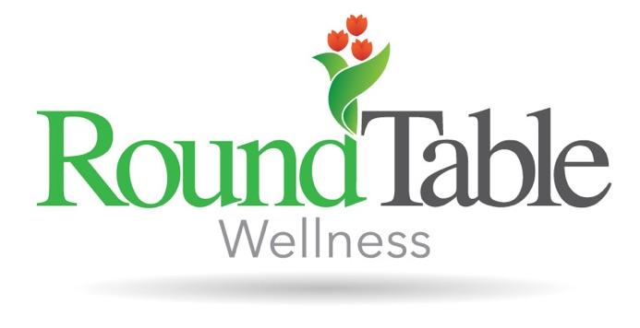
Leianna is a Registered Dietitian Nutritionist accredited by the Commission on Dietetic Registration. As an Ohio native, she earned her Bachelor of Science degree in Nutrition and Dietetics from The University of Akron. Prior to her work with RoundTable Wellness, Leianna worked within eating disorder treatment at the inpatient, residential, and partial hospitalization levels of care. Leianna strives to meet her clients where they’re at in their path to recovery and guides them through the next steps forward. She helps clients learn body respect through a lens of weight inclusivity and the Health at Every Size® perspective. With kindness and compassion, Leianna helps clients improve their relationship with food through an “all foods fit” and intuitive eating approach to nutrition therapy. Most of all, Leianna helps clients unlearn the harmful nutrition misinformation they have received from diet culture through evidence-based research, so they can begin to make peace with food and live free from an eating disorder.

